USDA Forest Service
Huron Shores Ranger Sation
5761 N Skeel Ave
Oscoda, mi 48750

Fire Effects of Slash Burning on Xeric Soils

On The Huron-Manistee National Forests

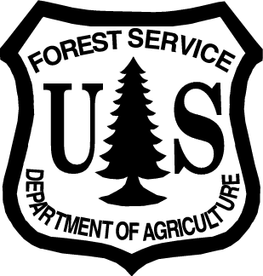

Prepared by: __/s/Brian Stearns________________ Date: ___11/13/2009_
Brian Stearns
Fire Equipment Operator
Huron Shores Ranger Station

Fire Effects of Slash Burning on Xeric Soils for the Huron Shores Prescribed Burning Program
The information in this summary is based on data gathered by the Huron Shores Prescribed Burning Program on the Huron-Manistee National Forest. The Data was collected from four prescribed burn projects implemented in six burn entries (some projects were broken into 2 burn units). The prescribed burn projects consisted of Brittle Burn Block 3 (667 acres), Brittle Burn Block 9 (698 acres), Jimny (184 acres), and Delightful (520 acres). All of the projects were located in the Tawas District of the Huron National Forest in Iosco County, Michigan (figure 1). The burn units are approximately 97% forested, have good ground cover, are almost entirely comprised of dry sandy plains, and major precipitation events occur when soils are frost-free. All of these conditions are very favorable for good water infiltration and sub-surface percolation. Overall, the watershed condition within the project areas is satisfactory due to the presence of forest canopy and litter cover over most of the area. Fuel loading on site was measured for Brittle Burn Block 3, 9, and Delightful Prescribed Burn, and estimated for the Jimny Prescribed Burn.

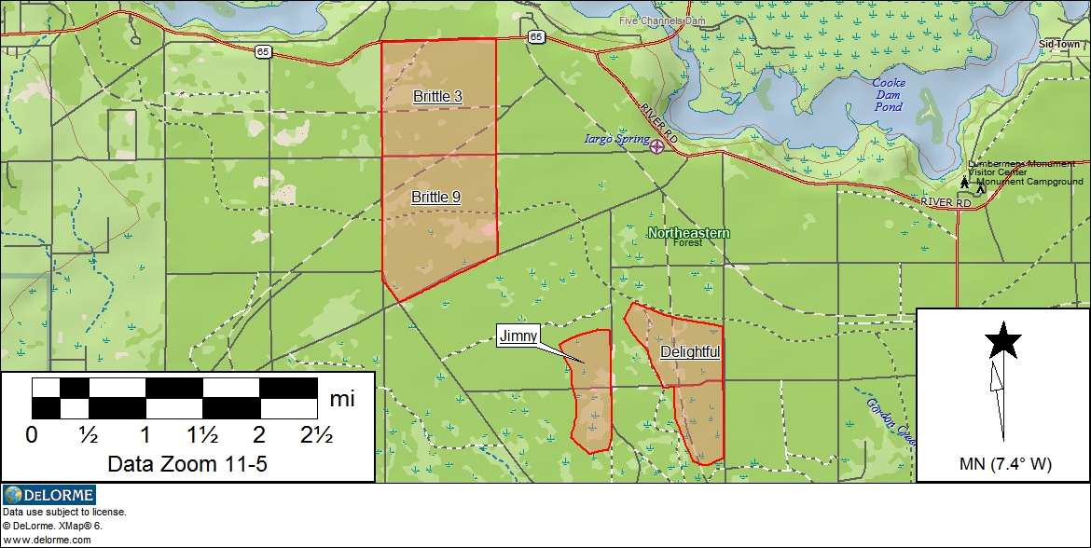
Figure 1. Area map showing the burn units.

Pre-Burn Conditions:
The majority of the soils in the project areas consist of poorly developed and well-drained sands with slopes less than 3%. The soils are nutrient–impoverished and contain less than 3% clay and 5% silt. Water tables are generally well below the tree rooting zone, typically 6 to 15 feet below the surface. Forest cover consists primarily of species adapted to xeric conditions and frequent fire, including jack pine, red pine, and northern pin oak. The soils and vegetation recover at average rates from disturbance activities.

The Soil Horizons measured on two test sites (pre-burn) are consistent with County Soil Surveys for Grayling Sand.
Soil Horizons | Average Depth in inches
O - | 1.2
A- | 0.9
E- | 0.2
C- | +36.0
Fig. 2 Soil test sites from Delightful Prescribed Burn (pre-burn).

Each of the projects contained a significant quantity of logging slash (Anderson’s fuel model 11). The objectives for the Jimny and Delightful Rx burns were site preparation for jack pine planting, and hazardous fuels reduction. The objectives of the two Brittle burns were primarily ecosystem restoration and fuels reduction, so they were burned in the spring. Between August and September of 2007 Browns’ transects were conducted in Brittle Blocks 3 & 9, averaging 13 plots each. Photo plots were also established for each transect. In July of 2009, four Browns’ transects were conducted for the Delightful burn and helped estimate the fuel loading for the Jimny burn.
Fuel Loading Information
Burn Unit | Average Tons / Acre | Average Litter Depth | Average Duff Depth
Brittle Block 3 | 9.7 | 1.3 | 0.8
Brittle Block 9 | 13.1 | 1.6 | 0.6
Jimny Rx Burn | 16.0 | 1.0 | 0.4
Delightful Rx Burn | 18.8 | 1.2 | 0.4
Fig. 3 fuel loading summary (pre-burn).
Pre-Burn Photos
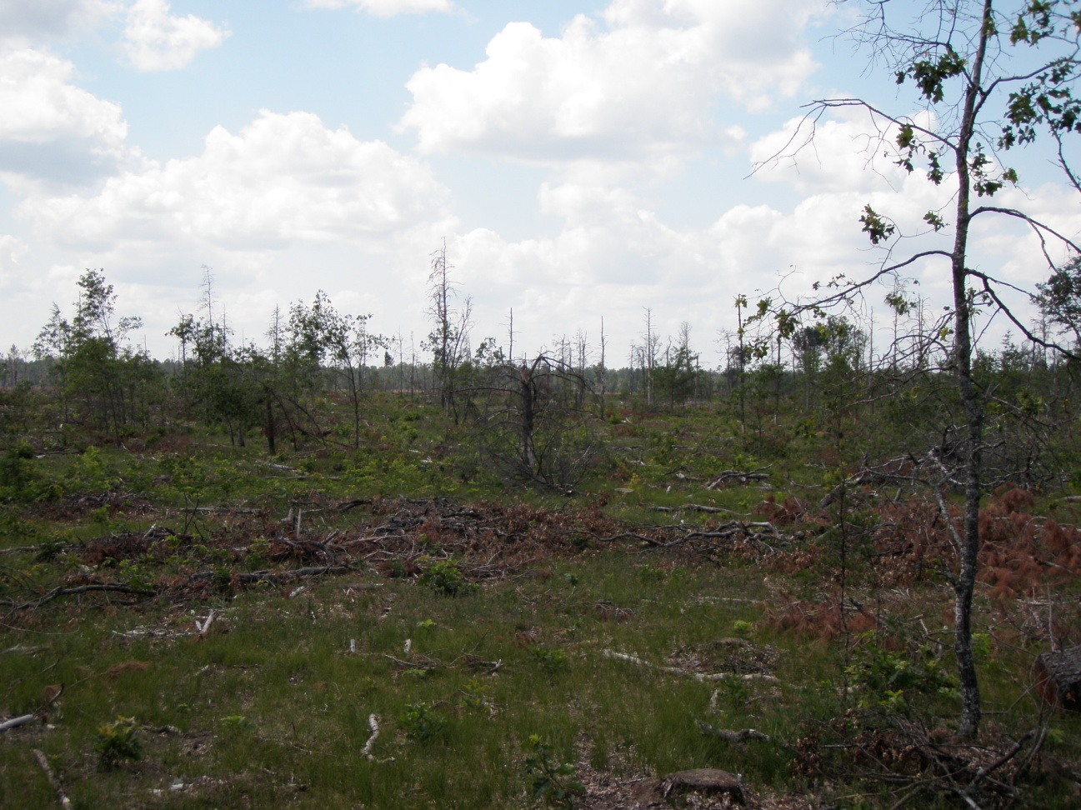
Delightful .
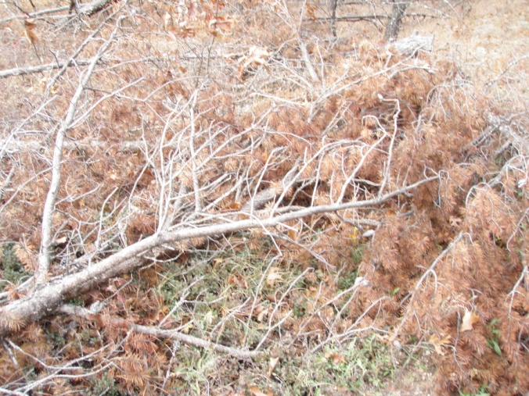
Fuel at Delightful
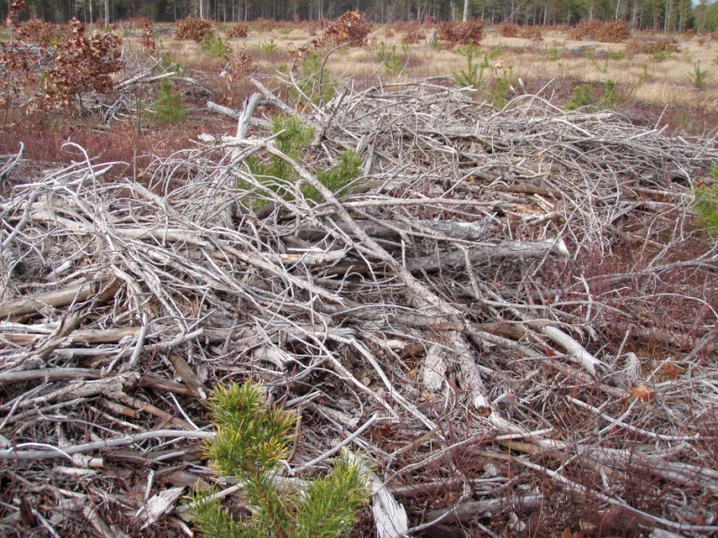
Delightful
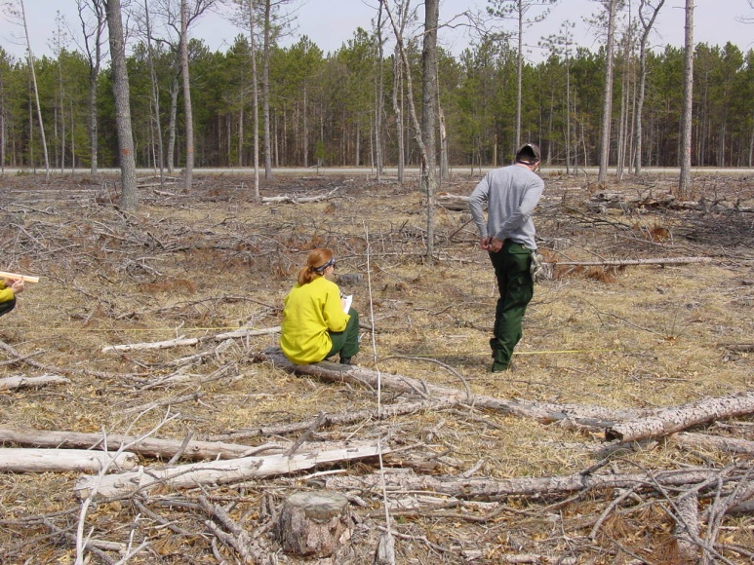
Brittle Block 3

Burn Day Observations:
DATE | Burn Name | Time of Burn | Day of Last Rain | Rain (in) | Temp (F) | Rh % | Wind Spd | Wind Dir | F.L. (ft) | R.O.S (ft/min) | Notes
4/17/08 | Brittle Block 9 | 14:00-16:30 | 04/12/08 (5) | 0.26 | 68-64 | 30-33% | 1 to 8 | SW to E | 2-8 (50') | 1 to 2 | Moderate slash within unit and wind change caused a crown fire.
4/17/08 | Brittle Block 3 | 17:00-20:00 | 04/12/08 (5) | 0.26 | 64-59 | 33-38% | 1 to 8 | E | 2 to 6 | 1 to 2 | Used flanking fire with helicopter
07/29/09 | Jimny (south) | 13:00-  1530 | 07/26/09 (3) | .38 | 73-75 | 40-44% | 5-8 | wnw | 2-9 | 2-4 | Good results
08/06/09 | Delightful north | 13:30-  1630 | 08/04/09 (2) | 0.15 | 73-80 | 49-62% | 0-5 | wnw/sw | 3-8 | 2-3 | 1 spot 50’x75’  Ice cap on column
08/07/09 | Jimny north | 14:00-15:00 | 08/04/09 (2) | 0.15 | 71 | 45-49% | 0-3 | e | 1-5 | 1-2 | 80 acres, good results
08/13/09 | Delightful south | 14:00-16:00 | 08/11/09 (2) | 0.11 | 80-82 | 49-57% | 0-3 | w/s | 2-7 | 1-2 | Flanking fire worked well
Fig. 4 Burn day summary.
Post-Burn Observations:
In all of the project areas post-burn evaluations show no significant damage to soils or watershed. In areas of concentrated fuels the typical results consisted of complete removal of litter. Duff layers had an average reduction of 1.0 inch, leaving an average of 0.2 inches. A noticeable response from warm season grasses occurred in Brittle Block 3 & 9. Both the Jimny and Delightful burns showed a rapid response of the herbaceous layer within two weeks of the burn. All four projects temporarily reduced the amount of forested coverage in the watershed, which increased the water yield; this means more water flows out of the watershed (Stone, et.al., 1978; Ursic and Douglas, 1978; Stone, 1975). For the Brittle Burn Blocks the vegetation was reestablished within one month, which is consistent with the publication sited (USDA 1986; Stone, et.al., 1978).
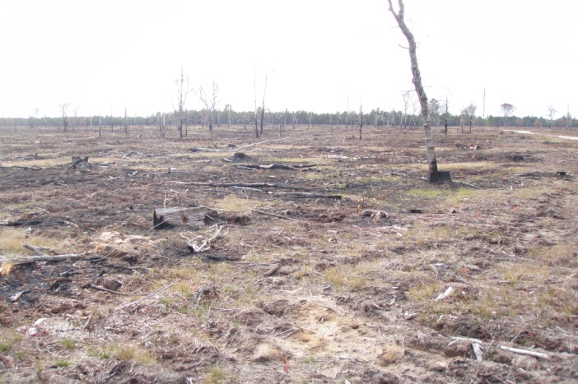
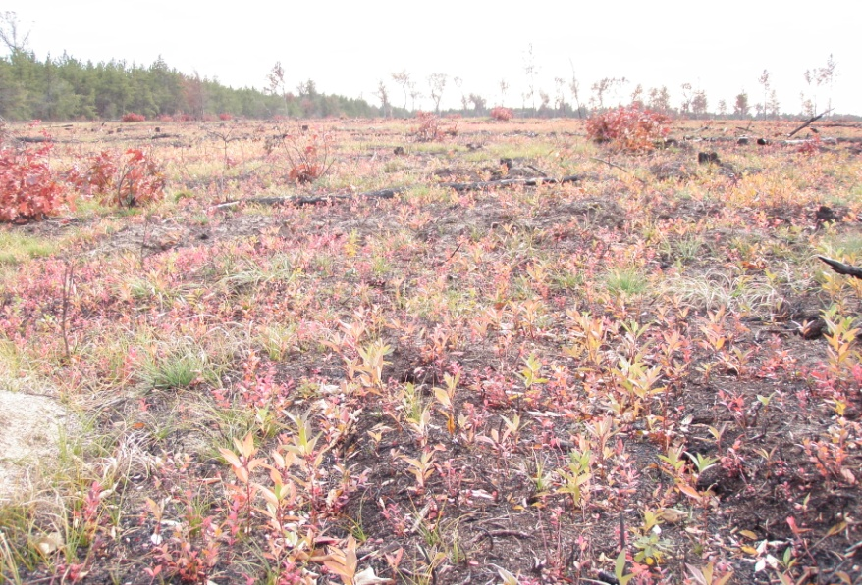
Jimny 2 months after the burn

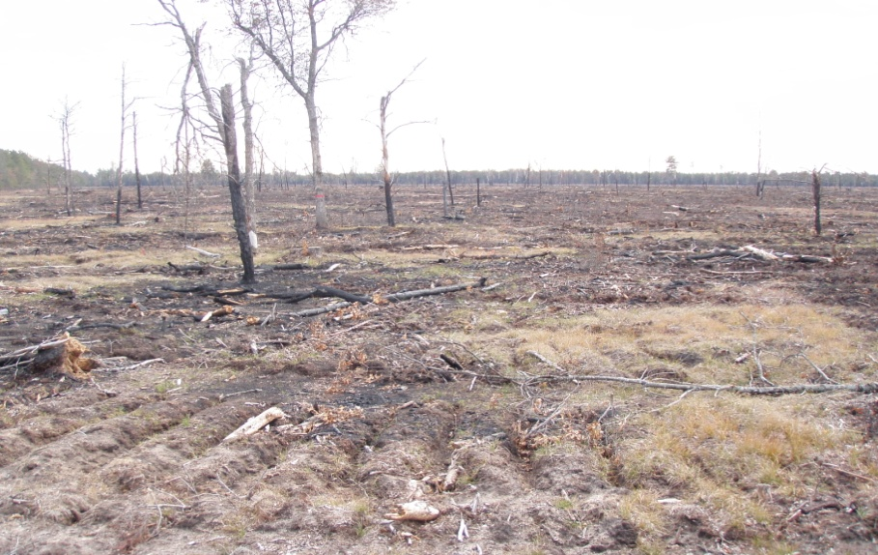
Delightful 1 week Post-Burn
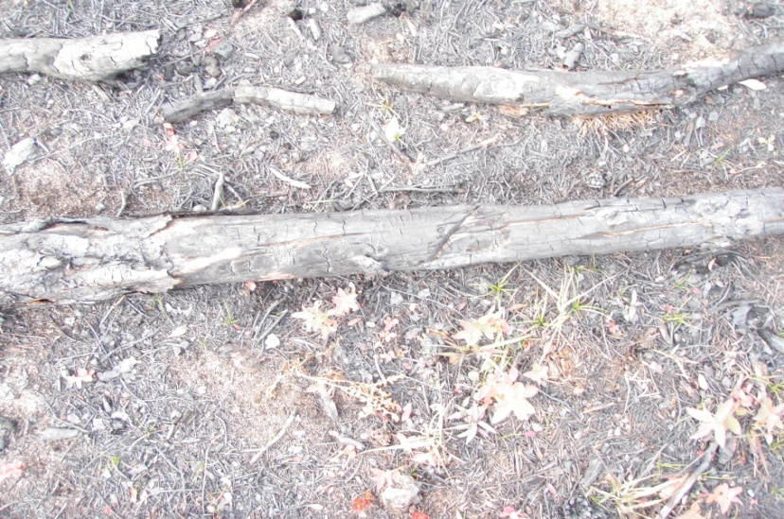
Delightful 1 week post Post-Burn.
The practice of pile burning has shown some significant impacts to the soils. The increase in fire intensity usually sterilizes the soils so only moss tends to grow at the sites (fig. 5). The typical burn duration for these piles is 1 hour+ and exceeds the recommended fire intensity. The effect of fire on soil properties is directly related to fire intensity and the resulting degree of exposure of mineral soil to heat. Soil stability is adversely affected by excessive heat. Soil properties are unaffected, or may even be enhanced, if the aboveground fuels are burned at sufficiently lower intensity so that soil temperature is not greatly increased (Wells, et.al., 1979). Prescribed fire used in forest management is designed to minimize damage to forest ecosystems by mitigating conditions that affect fire behavior and fire intensity.
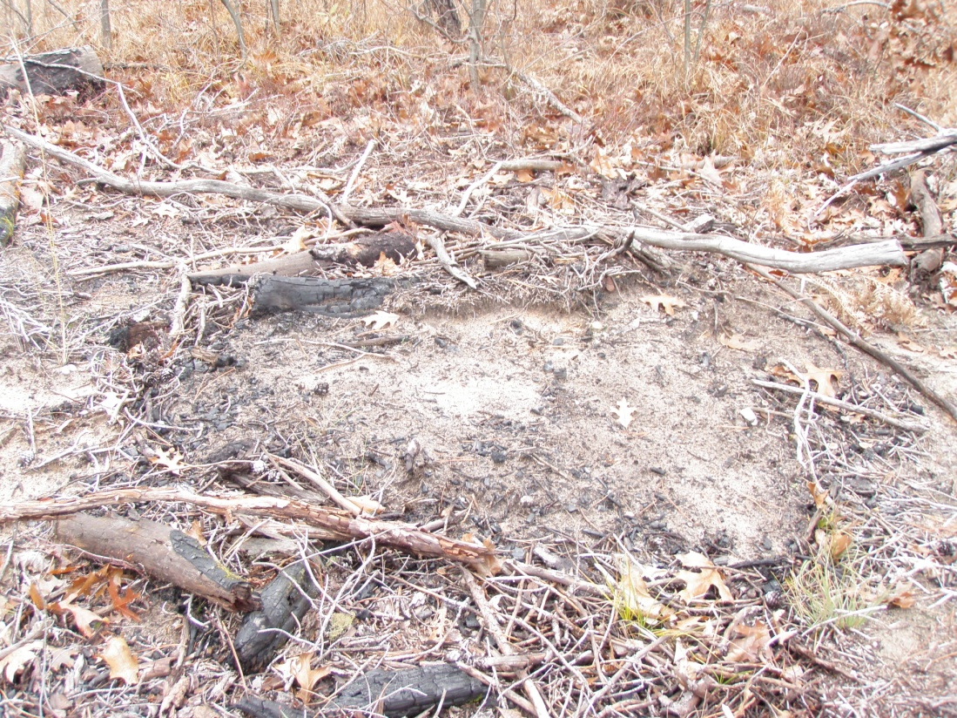
Fig. 5 Burn pile site 4 years after the burn.
Summary:

The fire impacts of slash burning on the xeric soils of the Huron-Manistee National Forest demonstrate an overall beneficial effect. The native herbaceous species seem to better outcompete invasive species, duff layers are reduced to less than 1 inch, and little or no erosion has been observed on the burn units. Pile burning does seem to sterilize the soil due to the increase in fire intensities, and often results in only sustaining the growth of moss. The observations and data collected for the Huron Shores Fuels Monitoring Program is consistent with information found on Fire Effects Information System www.fs.fed.us/database/feis/. Additional questions or request for plot data should be directed to:

Brian Stearns

Huron Shores Ranger Station

5761 N. Skeel Ave.

Oscoda, MI 48750

989-739-0728 ext. 3111

bstearns@fs.fed.us

References;
Neary, Daniel G.; Ryan, Kevin C.; DeBano, Leonard F. 2005. Wildland fire in ecosystems: effects of fire on soils and water. Gen. Tech. Rep. RMRS-GTR-42-vol.4. Ogden, UT: U.S. Department of Agriculture, Forest Service, Rocky Mountain Research Station. 250 p.
Benzie, John W. 2005. A Revised Manager’s Handbook for Red Pine in the North-Central States. USDA Forest Service Gen. Tech. Rep. NC-33, 22 p. North Central Forest Experiment Station, St. Paul, MN.
Marks, P.L. and F.H. Bormann. 1972. Revegetation Following Forest Cutting; Mechanisms for Return to Steady-State Nutrient Cycling. Science 176:914-915.
Cleland, David T. 1982. Review of Total Tree Harvest Impacts on the Soil Resource and Long-Term Productivity.

MDNR (Michigan Department of Natural Resources). 1994. Water Quality Management Practices on Forest Land. A publication of the Michigan Department of Natural Resources. 77 pp.
Pritchett, William L., Fischer, Richard F. 1987. Properties of Forest Soils: p. 251.
Stone, E.L. 1975. Nutrient Release through Forest Harvest; A Perspective. American Society of Civil Engineers Symposium on Watershed Management. Logan, Utah. 18 pp.
Stone, E.L., W.T. Swank, and J.W. Hornbeck. 1978. Impacts of Timber Harvest and Regeneration Systems on Stream Flow and Soils in the Eastern Deciduous Region. In. Forest Soils and Land Use. Proceedings Fifth North American Forest soils conference. Colorado State University. Pp. 516-535.
Ursic, S.J. and J.E. Douglass. 1978. The Effects of Forestry Practices on Water Resources. The W. Kelly Mosely Environmental Forum, Proceedings. Auburn University Press. Auburn, Alabama.
Wells, C.G. et.al., 1979. USDA Forest Service. Effects of Fire on Soil. General Technical Report WO-7. 34 pp.

